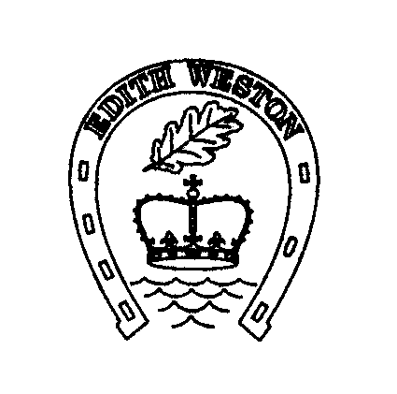
Edith Weston Parish Council

Parish Councillor Person Specification

COMPETENCY | ESSENTIAL | DESIRABLE
Relevant knowledge, Education, Professional Qualifications & Training | Sound knowledge and understanding of local affairs and the local community
Experience, Skills, Knowledge and Ability | - Solid interest in local matters  - Ability and willingness to represent the Council and their community  - Good interpersonal skills  - Ability to communicate clearly both orally and in writing  - Ability and willingness to work closely with other members and to maintain good working relationships with all members and staff  - Good reading and analytic skills  - Ability and willingness to work with the council’s partners (for example voluntary groups, other parish councils, principal authority, charities)  - Ability and willingness to undertake relevant training  - Ability to work under pressure | - Knowledge of HR, procurement, contract management, financial control or risk management and compliance, public relations  - Experience of working in another public body or not for profit organisation  - Experience of working with voluntary and or local community/ interest groups  - Basic knowledge of legal issues relating to town and parish councils or local authorities  - Experience of delivering presentation  - Experience of working with the media  - Experience in financial control/budgeting  - Experience of staff management
Other requirements | - Ability and willingness to attend meetings of the council (or the meetings of other local authorities and local bodies) in the evening and events in the evening and at weekends  - Willingness to accept and agree to abide by Council Code of Conduct  - Flexible  - Enthusiastic

